


A

Project Report
on

VIRTUAL FASHION ADVISOR: AN AI-BASED OCCASION-ORIENTED DRESS
RECOMMENDATION SYSTEM
submitted as partial fulfillment for the award of

BACHELOR OF TECHNOLOGY
DEGREE
SESSION 2025-26 in
Computer Science & Engineering
By
Ayushi Jaiswal (2200290100052)
Ananya Srivastava (2200290100021)
Anugya Gupta (2200290100033)
Avanish Prasad (2200290100047) Under the supervision of Mr. Rahul Kumar
KIET Group of Institutions, Ghaziabad
Affiliated to
Dr. A.P.J. Abdul Kalam Technical University,
Lucknow
(Formerly UPTU)
May, 2026

DECLARATION

We hereby declare that the project report entitled “Virtual Fashion Advisor: An AI-Based Occasion-Oriented Dress Recommendation System” submitted for the award of the degree of Bachelor of Technology is our original work. The work presented in this report has been carried out by us under the supervision of the faculty guide.
To the best of our knowledge, the work presented in this report has not been submitted previously for the award of any other degree or diploma of this or any other institution. Proper acknowledgment has been given wherever reference has been made to the work of others.

Name:- Ayushi Jaiswal
Roll No.:- 2200290100052 Signature

Name:- Ananya Srivastava
Roll No.:- 2200290100021 Signature

Name: Anugya Gupta
Roll No.:- 2200290100033 Signature

Name: Avanish Prasad
Roll No.:- 2200290100047 Signature

Date:-



CERTIFICATE

This is to certify that Project Report entitled "Virtual Fashion Advisor: An AI- Based Occasion-Oriented Dress Recommendation System" which is submitted by Ayushi Jaiswal , Ananya Srivastava , Anugya Gupta , Avanish Prasad in partial fulfillment of the requirement for the award of degree B. Tech. in Department of Computer Science & Engineering of Dr. A.P.J. Abdul Kalam Technical University, Lucknow is a record of the candidates own work carried out by them under my supervision. The matter embodied in this report is original and has not been submitted for the award of any other degree.

Mr. Rahul Kumar
(Faculty CSE)

Date:

Dr. Vineet K. Sharma
(DEAN CSE)

Date:

ACKNOWLEDGEMENT

It gives us a great sense of pleasure to present the report of the B. Tech Project undertaken during B. Tech. Final Year. We owe special debt of gratitude to Mr. Rahul Kumar, Department of Computer Science & Engineering, KIET Group of Institutions, Ghaziabad, for his constant support and guidance throughout the course of our work. His sincerity, thoroughness and perseverance have been a constant source of inspiration for us. It is only his cognizant efforts that our endeavors have seen light of the day.

We also take the opportunity to acknowledge the contribution of Dr. Vineet K. Sharma, Dean, Computer Science & Engineering Department, KIET Group of Institutions, Ghaziabad, for his full support and assistance during the development of the project. We also do not like to miss the opportunity to acknowledge the contribution of all the faculty members of the department for their kind assistance and cooperation during the development of our project. Last but not the least, we acknowledge our friends for their contribution in the completion of the project.

Name:- Ayushi Jaiswal
Roll No.:- 2200290100052 Signature

Name:- Ananya Srivastava
Roll No.:- 2200290100021 Signature

Name: Anugya Gupta
Roll No.:- 2200290100033 Signature

Name: Avanish Prasad
Roll No.:- 2200290100047 Signature

Date:-

ABSTRACT

Fashion recommendation is an emerging research field which connects technology to daily life.People often find it difficult to select attire which is appropriate for a particular occasion, comfortable, as well as socially or culturally acceptable. The Virtual Fashion Advisor (VFA) pro posed in this paper attempts to solve this issue by recommending clothes and draping styles for men and women. Traditional approaches for fashion recommendation systems have aimed largely at e-commerce personalization. This system attempts to emphasize on occasion specific appropriateness and cultural correctness.
The initial prototype employs Python dictionaries for rule- based mapping of attire with filters (occasion, time of day, comfort, and gender). The architecture is designed for scalability into ML-driven models,with integration possibilities for real-
time datasets and virtual try-on systems. Testing with a sample dataset yielded an estimated accuracy of ∼82% in matching user expectations with recommendations. This paper discusses the sys- tem architecture, methodology, dataset schema,
implementation details, limitations, and future enhancements to make the VFA a comprehensive digital fashion companion.
Index Terms—Fashion recommendation, Virtual Fashion Ad- visor, Rule-based system,Occasion-aware attire, AI in fashion

TABLE OF CONTENTS Page No.

DECLARATION......................................................................................................... 2
CERTIFICATE............................................................................................................ 3
ACKNOWLEDGEMENT........................................................................................... 4
ABSTRACT................................................................................................................. 5
LIST OF FIGURES..................................................................................................... 8
LIST OF TABLES....................................................................................................... 9
LIST OF ABBREVIATIONS...................................................................................... 10
CHAPTER 1(INTRODUCTION)............................................................................... 6
  - Introduction..........................................................................................................
  - Project Description...............................................................................................
  - Project Statement...............................................................................................
  - Objective...............................................................................................
  - Project Scope...............................................................................................
  - Importance of the Project.......................................................................................
  - Disadvantage of the Present Systems....................................................................

CHAPTER 2 (LITERATURE REVIEW).................................................................... 18
  - Introduction..........................................................................................................
  - Conventional Recommended System.................................................................
  - Recommendation Based on Deep Learning.......................................................
  - Context Aware Recommendation System..........................................................
  - Rule Based Recommendation System................................................................
  - Multimodal Recommendation System................................................................
  - Summary...............................................................................................

CHAPTER 3 (PROPOSED METHODOLOGY)....................................................... 27
3.1 An Overview of the Proposed System..................................................................
  - System Architecture Design....................................................................................
3.2.1 Architectural layers........................................................................................
  - Registration and Data Gathering.............................................................................
3.3.1 Registration Process........................................................................................
3.3.2 Behavioral Data Collection..............................................................................
  - User Modelling and Preference Learning......................................................................
  - Body and Style Assessment................................................................................................
3.5.1 Body Shape Categories................................................................................................
3.5.2 Method................................................................................................
3.5.3 Procedure................................................................................................
3.5.4 Recommendation Mapping................................................................................................
3.5.5 Reasoning................................................................................................
3.6 Dataset and Knowledge Base Creation................................................................................................
3.6.1 Dataset Sources................................................................................................
3.6.2 Dataset Schema................................................................................................
3.7 Rule Based Recommendation Engine..........................................................................................
3.8 Collaborative Filtering and Recommendation System................................................................
3.9 Personalization with Reinforcement learning..............................................................................
3.10 Natural Language Interview Query............................................................................................
3.11 Integrating awareness of Current Trends, Markets....................................................................
3.12 Frontend and Backend Technology............................................................................................
3.13 Feedback and Learning...............................................................................................................
3.14 Privacy and Security...................................................................................................................
3.15 Performance Evaluation Metrics................................................................................................
3.16 Future Hybrid Exp......................................................................................................................
3.17 Proposed Methodology (Conclusion).........................................................................................
CHAPTER 4 (RESULTS AND DISCUSSION)........................................................ 21
CHAPTER 5 (CONCLUSIONS AND FUTURE SCOPE)........................................ 25
  - Conclusion…........................................................................................................
  - Future Scope.........................................................................................................
REFERENCES............................................................................ 27
APPENDIX............................................................................... 29

LIST OF FIGURES

Figure No. | Description | Page No.
1 | System Architecture of Virtual Fashion Advisor | 12
2 | Structure of the Python dictionary | 20
 | used for fashion rule mapping
3 | Quiz for user filteringbased on | 22
 | occasion
4 | Quiz for user filteringbased on | 23
 | body type
5 | Recommended Men and | 23
 | women wears
6 | Accessories and seasonal | 23
 | recommendations
7 | Latest Fashionnews fetched | 23
 | throughNewsAPI
8 | Latest Style Guide | 23
9 | Body Types | 24

LIST OF TABLES

Table No. Description Page No.
1 Literature Review of Fashion 16
Recommendation Techniques
2 Sample Dataset Schema 17
3 Tools and technologies used 17
4 Sample Execution 18

LIST OF ABBREVIATIONS

AI Artificial Intelligence
VFA Virtual Fashion Advisor
ML Machine Learning
CNN Convolutional Neural Network
RNN Recurrent Neural Network
API Application Programming Interface
NLP Natural Language Processing
CV Computer Vision
UI User Interface
UX User Experience
JSON JavaScript Object Notation
KNN K-Nearest Neighbors
GNN Graph Neural Network
AR Augmented Reality
DL Deep Learning

CHAPTER 1

INTRODUCTION

INTRODUCTION

Fashion is an essential part of modern life and acts as a medium for self-expression, cultural representation, and professional presentation. Clothing choices often influence how individuals are perceived in social and professional environments. However, selecting the appropriate attire for different occasions can be challenging because individuals must consider several factors such as occasion, weather conditions, cultural norms, comfort level, and personal preferences.
With the advancement of technology, artificial intelligence and recommendation systems have been increasingly used to assist users in making better decisions. In the fashion industry, recommendation systems are widely used in e-commerce platforms to suggest clothing items based on user behavior, purchase history, and browsing patterns. However, many existing systems focus primarily on product recommendations rather than offering contextual fashion advice.
The concept of a Virtual Fashion Advisor aims to bridge this gap by providing outfit recommendations that are tailored to specific occasions and user preferences. The system analyzes factors such as event type, gender, time of day, and comfort level to recommend appropriate clothing combinations. This approach helps users avoid inappropriate fashion choices and reduces decision fatigue when selecting outfits.
The proposed system uses a rule-based recommendation engine implemented in Python. The rule engine maps user inputs to outfit suggestions using predefined fashion guidelines. Unlike complex machine learning systems that require large datasets and training processes, the rule-based approach offers transparency, simplicity, and easy customization.

A. System Architecture
The system architecture is designed in a modular way so that it can be extended in the future to incorporate advanced technologies such as machine learning, computer vision, and augmented reality. These technologies can enable features like personalized recommendations, body-type analysis, and virtual clothing trials.
Overall, the Virtual Fashion Advisor system demonstrates how a simple yet effective rule-based approach can provide useful fashion recommendations while serving as a foundation for future AI-driven fashion advisory platforms.

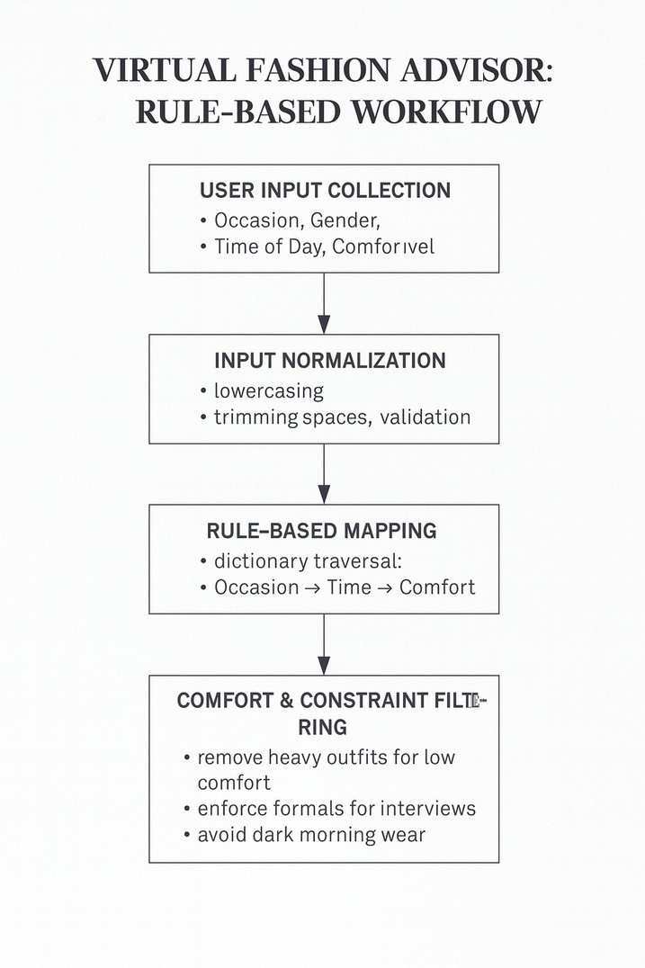
Fig. 1. System Architecture of Virtual Fashion Advisor

1.2 PROJECT DESCRIPTION

The Virtual Fashion Advisor is a smart recommendation system that suggests outfits based on users' input such as event, gender, time of day and comfort level. The system is built using a rule-based methodology, where a set of rules are used to determine clothing suggestions based on the input parameters.

The system operates in a process flow. Initially, the user enters their requirements. The system then processes these inputs and maps them to the rules stored in the system. The system then produces a list of appropriate outfits. Further filtering is done to ensure that the suggestions adhere to comfort and context constraints.

Our project aims to achieve occasion-specific and user-specific recommendations, which sets it apart from other systems. For instance, it can recommend formal dresses for interviews, ethnic clothes for weddings and light clothes for parties. The system can also give culturally relevant and practical suggestions.

The system is easy to use, simple and efficient. It offers fast response times with low computational complexity. Additionally, this architecture is flexible and can be enhanced to incorporate new technologies like machine learning, natural language processing and virtual try-on.

1.3 Problem Statement

The rapidly growing number of clothing options is making it difficult for users to choose the right outfits. The identified problems are:
The number of options overwhelms users.
Current systems are not aware of the context (e.g. time, event).
Generalized recommendations are provided.
They do not consider comfort and culture.
Styling tips are not given.
So, we need a system which provides smart, personalized and contextual outfit recommendations.

1.4 Objectives

The main goal of this project is to build the Virtual Fashion Advisor - an intelligent system to help users choose suitable outfits according to their needs. The system will make fashion selection easy and convenient by offering tailored recommendations.

The project's specific goals are:

- To develop a recommendation system: The system must be able to process a user's input about occasion, gender, time of the day and wearer's need for comfort and suggest appropriate outfits. The aim is to develop an efficient and user-friendly system.

- To offer contextualized outfit recommendations: The project is to build a new system that will take into account contextual attributes such as the occasion (for example wedding, interview, party), time of the day (morning, evening), and cultural considerations to provide relevant recommendations.

- To develop a rule-based system in Python: It employs a structured rule-based system, with rules hard-coded as Python dictionaries. This allows for rapid processing, reduced calculation cost, and results are easily explained.

- To address comfort and other usability aspects: Our system takes into account user comfort as an important factor by eliminating unsuitable clothing items based on the comfort level chosen by the user. This guarantees practical and wearability.

- To ensure transparency and explainability: The rule-based approach enables users and developers to easily understand how recommendations are made, as opposed to black-box machine learning models.

- To evaluate system performance: This project intends to evaluate the performance of the system in terms of accuracy, response time and user satisfaction using sample test cases and metrics.

- To build a future and extensible system: The system is built with an architecture that would allow it to be scalable in the future by using more sophisticated technologies like Machine Learning, Natural Language Processing and Computer Vision to further improve personalization .

1.5 Project Scope

The Virtual Fashion Advisor project is primarily concerned with a design and development of a rule-based system that offers smart outfit recommendations according to certain pre-defined criteria. The aim of the project is to solve the real-life problem of selecting an outfit.

The system mainly addresses the following issues:

- Occasion-based recommendations: The system offers recommendations for different occasions like weddings, interviews, parties and casual outings. Different occasions have different dress code that is reflected by the rule engine.

- Time-based recommendations: Apparel may be different depending on the time. The system takes into account time parameters like morning, afternoon, evening and night for recommending clothing.

- Comfort-level filtering: This system enables the user to indicate preferred comfort levels (e.g., low, medium, high), which the system takes into account. This guarantees that outfits are comfortable.

- Gender-specific recommendations: It takes into account specific gender preferences and makes recommendations based on that.

- Basic styling guidance: It may also offer styling advice to enhance the look.

But the current project is limited in the following aspects:

- It uses a rule-based system, rather than large machine learning models.
- It lacks real-time information, such as fashion trends and weather.
- It is a prototype, rather than having a live web or mobile interface.
- Although not without limitations, the project lays the groundwork for future improvements such as AI personalization , AR virtual fitting rooms and real-time recommendations.

1.6 Importance of the Project

The Virtual Fashion Advisor is important from both an educational and practical perspective. It shows the successful use of technology to address problems in the fashion industry.

The project's significance is reflected in:

Reduction of decision fatigue:
The system offers a selection of outfits, reducing the overwhelm of choice.

Improved user experience:
The system streamlines the outfit selection process, making it quicker and easier for users.
Personalized recommendations:
The system involves several user-related factors, so that the recommendations are personalized.

Context-aware decision making:
Considering the occasion, time and comfort, makes the decision making process more applicable.

Transparency and trust:
Using a rule-based system provides transparency in how suggestions are made, enhancing user trust.

Academic value:
This project is a practical application of topics such as rule-based systems, data structures and system design.

Foundation for future innovations:
The system could be enhanced with new AI capabilities like machine learning, natural language processing and computer vision, and could be a foundation for future work.

1.7 Disadvantages of Present Systems

The current fashion recommendation systems, especially those in e-commerce systems, have some drawbacks that limit their usefulness in practice.

Dependence on historical data:
Recommendations are heavily reliant on historical data (purchases, browsing) They are therefore unable to handle new users or drifting user interests.

Lack of contextual understanding:
Traditional recommendations do not take into account factors like context, time, and cultural significance, leading to inappropriate recommendations.

Limited personalization:
The suggestions are generic and do not consider individual preferences, body shapes or comfort needs properly.

High computational complexity:
Machine learning-based approaches need high computational resources and large datasets to train the model.

Lack of explainability:
Such systems are often treated as black boxes and it is not clear how the recommendations are made.

Lack of consideration for real-life use cases:
Some of the current systems primarily focus on product advertising, limiting their real-world applications.

The aforementioned constraints suggest that we need a simple, efficient and transparent system, such as the rule-based Virtual Fashion Advisor that focuses on practical recommendations to the user.

CHAPTER 2

LITERATURE REVIEW

2.1 Introduction

The field of fashion recommendation systems has gained increasing attention with the advancement of artificial intelligence and machine learning technologies. Researchers have explored different techniques including deep learning ,collaborative filtering, and multimodal recommendation systems to improve fashion recommendation accuracy.
Early research in fashion recommendation primarily focused on visual similarity models using convolutional neural networks. These models analyze images of clothing items to determine similarity between fashion products and suggest related items to users. While these approaches are effective in identifying visually similar products, they often fail to consider contextual factors such as occasion, cultural norms, or user comfort preferences.

Another important approach involves visual-semantic embedding techniques, where fashion items are represented in a joint visual and textual feature space. This approach enables systems to understand relationships between clothing items based on both images and descriptions. Although these models improve compatibility prediction between fashion items, they still lack personalization based on user context.

Recent studies have introduced attention-based neural networks to analyze outfit compatibility. These networks identify important clothing components with in an outfit and determine how different items interact with each other. However, these approaches are usually limited to outfit-level compatibility and do not account for contextual dressing requirements such as formal events or cultural ceremonies.

Researchers have also explored temporal and trend-aware recommendation systems using recurrent neural networks. These systems analyze social media data and fashion trends to predict future clothing styles. While this approach improves trend prediction, it does not necessarily provide personalized recommendations for specific events.

Hybrid recommendation models combining visual features, textual descriptions, and customer reviews have also been proposed. These systems improve recommendation quality but often require significant computational resources and large datasets.
Despite these advancements, many existing fashion recommendation systems still lack
explainability and contextual awareness. Most systems prioritize predictive accuracy but do not clearly explain the reasoning behind recommendations. Additionally, factors such as body type, cultural traditions, and occasion-specific dressing guidelines are rarely considered.

These limitations highlight the need for a more interpretable and context-aware recommendation system. The Virtual Fashion Advisor addresses this gap by using a rule-based approach that incorporates occasion-based reasoning, comfort preferences, and cultural fashion norms.

2.2 Conventional Recommendation Systems

Traditional recommendation systems are the building blocks of current intelligent recommendation systems and have been successfully applied in a range of industries including e-commerce, media and online services. These systems rely primarily on statistical techniques and mathematical models to examine user actions, item properties and user-item interactions to make recommendations. Specifically, in the fashion domain, conventional recommendation systems seek to recommend clothing items using features such as product descriptors and user interactions with the items. While such systems have been successful in many domains, there are some limitations to their use in the fashion industry, which is highly personal and context sensitive.

A popular method employed in conventional recommendation systems is content-based filtering. This approach is based on the items' properties and the user's profile. In the context of fashion recommendations, clothing items are represented by attributes like color, material, pattern, style and type. A user profile is created from the items they have chosen or rated highly and the system recommends items similar to these. The idea is that users will like items similar to those that they have selected previously. Similarity is usually computed based on mathematical formulae such as cosine similarity or Euclidean distance. Although content-based filtering is good at providing user-specific recommendations and is easy to implement, it is prone to over-specialization, limited diversity and is difficult to incorporate novelty. Moreover, it fails to account for the context of the occasion or weather, which play a significant role in making fashion choices.

Collaborative filtering is another popular approach, which uses user ratings data instead of the features of items. It is based on the assumption that users with similar tastes in the past will also have similar tastes in the future. Collaborative filtering can be broken down into user-based and item-based collaborative filtering. User-based collaborative filtering identifies similar users and recommends items that they have rated highly. Item-based collaborative filtering, on the other hand, suggests items that are similar to items the user has rated positively. Collaborative filtering can capture implicit user preferences and offers more varied recommendations than content-based filtering. But collaborative filtering has its limitations, such as the cold-start problem, in which new users or items do not have enough information for generating recommendations. Moreover, problems related to data sparsity and scalability can also impact the system's effectiveness, particularly at large scales.

To address some of the weaknesses of each technique, hybrid recommendation systems merge content-based and collaborative filtering approaches. These systems can integrate the advantages of both approaches and reduce their disadvantages. For instance, a weighted hybrid model may integrate the results of the two techniques to provide more precise recommendations, while a switching hybrid system may adaptively select the best approach to use in a given situation. These approaches are often more accurate and are able to address problems such as cold-start and data scarcity. But hybrid systems are more complex systems, with increased computational power demands, making them difficult to design and implement.

Although traditional recommendation systems are commonly used in various applications, they have some drawbacks in the fashion industry. First, the systems lack context-awareness, as they usually do not take into account aspects like time of day, season, weather conditions or cultural constraints. They also lack visual awareness, which is important in the fashion industry, as style and look are considered significant factors. Additionally, these systems usually offer product-based recommendations rather than ensemble recommendations, limiting their practical applications in real-world applications.

Traditional recommendation systems are extensively adopted in the fashion industry in e-commerce sites like online shopping sites and fashion apps. These aid users in finding products based on their search and purchase history. But their aim is largely to boost sales rather than offer valuable fashion advice. This may lead to recommendations that are relevant but not relevant in the right context.

To conclude, traditional recommendation systems offer a good base for developing smart recommendation systems. Content-based filtering, collaborative filtering and hybrid recommendation systems have played a crucial role in the advancement of recommendation systems. But their shortcomings, especially with regard to the consideration of context, personalization and practicality, calls for more sophisticated technologies. This calls for systems like the Virtual Fashion Advisor that can take into account contextual information, explainability and user needs in the design of recommendation systems.

2.3 Recommendation Systems Based on Deep Learning

The rise of Artificial Intelligence (AI) has led to the introduction of deep learning technologies, which have really boosted the effectiveness of recommendation systems, particularly in the fashion industry where visual recognition is important. Unlike traditional recommendation systems, which utilize hand-crafted features and statistical approaches, deep learning techniques can learn hierarchical and abstract features directly from large amounts of data. They are particularly suitable for dealing with unstructured data, such as images and textual descriptions.

A popular deep learning algorithm used for fashion recommendation is the Convolutional Neural Network (CNN). CNNs are ideal for image analysis, and can learn rich features like textures, patterns, shapes and colours from fashion images. Within the context of fashion systems, CNNs compare the visual compatibility between products and generate stylistically similar outfits. For instance, a CNN-based fashion system can determine the compatibility of a shirt with jeans. While CNNs are accurate, they need large amounts of annotated data and computing power, which may be costly for small-scale systems.

Another crucial technique is Recurrent Neural Networks (RNNs) and sequence models, which are effective for handling time series data like user interactions and trends. These networks can capture the dynamic nature of user preferences and make recommendations based on past search history. For example, if a user's tastes evolve from informal to formal garments, an RNN-based model can adjust to their changing preferences and recommend appropriate clothing.

Recently, deep learning has also brought about a notion of visual-semantic embedding, which involves projecting images and textual descriptions into a joint space. The system can therefore grasp the connections between visual and semantic content. This helps the system understand that a dress is "elegant" or "formal", while making more accurate recommendations. But these models are intricate and need extensive training data.

Another recent development is attention models, which emphasise key aspects of outfits. These assist in recognizing critical clothing items that contribute to an outfit's style, enabling better recommendations. Other research has investigated the use of Graph Neural Networks (GNNs) to capture the relationships between clothing elements, allowing for whole outfit recommendations.

Although deep learning systems are beneficial, there are some drawbacks. They require significant computational power, are data-hungry and can be less explainable, complicating the understanding of recommendations. These issues can make them difficult to deploy in lightweight systems.

2.4 Context-Aware Recommendation Systems

Context-aware recommendation systems go beyond traditional systems to include other information to make more useful recommendations. For fashion, context is especially important as apparel choices are influenced by a variety of external factors, such as occasion, time of day, weather and cultural background.

In contrast with traditional approaches which are based only on user preferences or previous interactions, context-aware systems take multiple factors into account. For instance, a marriage ceremony might require different attire than an interview. Likewise, clothing choice depends on the weather, and cultural customs dictate what to wear on certain occasions.

Recommendation systems can integrate context in various ways. In pre-filtering approaches, context is used to filter data prior to making recommendations. Post-filtering approaches use context after the recommendations have been produced. The most sophisticated methods actually integrate contextual information into the recommendation generation process to provide more precise recommendations.

Using context greatly enhances the quality and effectiveness of recommendations. Recommendations are not only applicable but also directly useful in the context of interest. But the addition of context raises other issues, including higher data complexity, data integration issues and dynamic nature of context.

2.5 Rule-Based Recommendation Systems

Rule-based recommendation systems are straightforward and explainable intelligent systems. These rely on pre-established rules and guidelines, often based on expert advice in a particular field of expertise. For fashion recommendations, rule-based systems use user parameters like event, gender, time and comfort level to recommend suitable outfits.

The main principle of a rule-based system is an IF-THEN mode, which means if certain conditions are met, certain actions are taken. If the user inputs an occasion of wedding and female gender, the system might recommend traditional wedding gowns like sarees and lehengas. This approach ensures decisions are consistently made and easily understood.

The benefit of using a rule-based approach is that it is explainable. The transparency of their reasoning allows explanation and validation of the recommendations, overcoming the black-box problem common in machine learning models. Moreover, they are fast, do not require a data set to train, and can be easily expanded.

But there are also drawbacks to rule-based systems. They work with a fixed rule base and are not able to automatically learn from the latest trends or user behavior. Managing the rules becomes more difficult as they become numerous. However, rule-based systems are extremely well suited for prototypes and transparent applications.

2.6 Multimodal Recommendation Systems

Multimodal recommendation systems are a more sophisticated solution, which uses different forms of data to enhance recommendations. For fashion, this means combining visual information (images), textual information (descriptions) and interaction information.

Multimodal systems have the advantage of including various features of the product. Images convey details about colour, shape and pattern while textual information reveals details about the fabric type, style etc. This allows the system to have a more complete view of fashion items.

These systems often rely on deep learning networks to learn features from each modality, and merge them into a single representation. This can lead to better and more relevant recommendations. A multimodal system, for instance, can suggest clothes that look good together and also fit with the user's style description.

But multimodal systems are complicated to build and demand high computational resources. Using multiple data sources also introduces issues of data integration and synchronization.

2.7 Summary

To summarize, this chapter has covered several approaches in fashion recommendation systems such as traditional systems, deep learning, context-aware systems, rule-based systems and multimodal systems. Each approach has its own strengths, as well as drawbacks.

Multimodal and deep learning systems are highly accurate but resource-intensive and non-explainable. Traditional systems are simpler but don't fit contextual needs. Rule-based systems are explainable and efficient but in flexible.

These insights suggest the need for a hybrid approach drawing on different approaches. The Virtual Fashion Advisor presented in this paper is based on a contextualized rule-based approach and offers an efficient solution for fashion recommendation in practice. .

TABLE I
Literature Review of Fashion Recommendation Techniques
Ref.

[1]

[2]

[3]

[4]

[5]

[6]

[7]

[8]

[9]

[10]

[11]

[12]

[13]

[14]

[15]

[16]

[17]

[18]

[19]

[20]
Technique

Deep CNN + Collaborative
Visual-semantic embedding
Attention-based neural net-
KERN (RNN-based) (2020)
CNN + Attribute classifiers
Hybrid CNN + Text mining
Multi-modal deep learning
Graph Neural Network (2021)
Deep learning survey (2022)

Review paper (2022)

ML with user profiling (2022)
Deep ranking models (2022)

CNN + KNN (2023)

Collaborative filtering
+

Review of hybrid recom-
Content-based filtering (2023)
Deep CNN + attribute learn-
Vision + NLP models (2024)
Image-based retrieval (2024)
Rule-based + context rea-
Data Used

Amazon Fashion dataset
Fashion images and tags

Polyvore outfits

Instagram fashion trends

Street fashion dataset

Images and descriptions

Images and reviews

Outfit networks

Multiple datasets

Fashion recommender systems

Commercial user data

Click and purchase data

Fashion image datasets

Body shape and preferences

Benchmark datasets

Clothing attributes

Fashion catalog images

Images and descriptions

User-uploaded photos

Occasion, weather, body type
Key Features

Learns style compatibility from im-
Outfit compatibility via learned em-
Identifies clothing parts influencing
Time-aware fashion trend prediction
Attribute-based style reasoning
Mix-and-match and similarity rec-
Incorporates customer feedback
Models item-item compatibility
Emphasis on explainability and at-
Covers style, fit, and personalization
Real-time personalized fashion feeds
Context-aware fashion ranking
Visual similarity-based recommen-
Body-aware personalization
Analysis of modern hybrid systems
Attribute-driven recommendations
Improved content- based personaliza-
Multimodal fashion understanding
Visual search for similar clothing
Explainable, low-data recommenda-
Limitations / Scope

No body-type or occasion aware-
Lacks user personalization
Limited to outfit-level data
No body or fit modeling
Requires heavy annotation
Depends on keyword quality
Computationally expensive

Hard to scale

Limited interpretability

Mostly conceptual

Proprietary data dependency

Not body-type aware

No outfit compatibility modeling

Limited scalability

No implementation details

Cold-start problem

Large training data required

Complex model design

No complete styling advice
Limited adaptability without ML

TABLE II
Sample Dataset Schema
Occasion
Wedding Wedding Interview Interview Party Party
Gender
Male Female Male Female Male Female
Time
Evening Morning Morning Afternoon Night Night
Comfort
Medium High Medium High Low Medium
Recommended Attire
Sherwani, Kurta- Pajama
Saree, Lehenga

Formal Shirt, Blazer, Tie
Saree, Formal Suit Casual Shirt, Blazer
Cocktail Dress, Saree

TABLE III
Tools and technologies used
Tool / Library

Python 3.10

json (built-in)

typing (built-in)

Flask / FastAPI (opt.)

GitHub
Purpose

Core language for rule logic
Data formatting & logging

Type hints

Future API integration

Version control

TABLE IV
Sample Execution
Input (Occasion, Gender, Time)
Wedding, Female, Morning
Output Recommendation
Light Saree, Lehenga Shirt & Tie, Blazer

CHAPTER 3

PROPOSED METHODOLOGY

3.1 An Overview of the Proposed System
The Virtual Fashion Advisor (VFA) is an intelligent, AI-powered web recommendation system that offers users a virtual style assistant to suggest outfits according to several contextual and personal aspects such as body type, skin tone, gender, occasion, weather, current fashion trends, user comfort and personal style. The system seeks to combine the advantages of traditional static fashion recommendation systems and dynamic interactive digital styling solutions by leveraging Artificial Intelligence (AI), Machine Learning (ML), Collaborative Filtering (CF), Reinforcement Learning (RL), Natural Language Processing (NLP) and web technologies.
The proposed methodology is geared towards ultra-personalization, transparency, adaptability, and real-time user engagement, rather than the static nature of conventional fashion recommendation systems that are generally based on general market trends, or on past purchase history. The system is initially built upon a rule-based system for its transparency and efficiency, but designed with the option to evolve into hybrid and AI-powered recommendation platforms.

The proposed methodology has the following phases:
1. Registration and Data Gathering
2. User Modeling
3. Size and Style Analysis
4. Data Set and Knowledge Base
5. Rule-Based Recommendation Engine
6. Collaborative Filtering Recommendation
7. Reinforcement Learning-Based Dynamic Personalization
8. Natural Language Processing (NLP) User Interface
9. Trend and Market Integration (Real time)
10. Frontend-Backend System Development
11. Database Management
12. Continuous Development through Feedback
13. Planning for Deployment, Security and Scalability

3.2 System Architecture Design
The Virtual Fashion Advisor is based on a layered and modular architecture to support scalability, maintainability and extensibility.

3.2.1 Architectural Layers
1. Front-end (Presentation) Layer
This offers an interface to the user in the form of:
- Registration/Login forms
- Fashion quizzes
- Body shape questionnaires
- Personalized dashboards
- Outfit recommendations display
- Trend/news sections
- Shopping links
- OOTD showcase
- Technologies Used:
- React.js / Next.js
- Tailwind CSS
- JavaScript/TypeScript
- ShadCN UI Components
Reasoning:
New generation of frontend frameworks guarantee:
- Responsive design
- Real-time updates
- Enhanced user engagement
- Modular UI components
- Cross-platform compatibility

2. Business Logic (Backend)
Responsible for:
- User authentication
- Data preprocessing
- Recommendation generation
- Rule engine execution
- API integration
- RL adaptation
- Collaborative filtering logic
Technologies Used:
- Python
- Flask / FastAPI / Django
- Node.js (optional)
Reasoning:
Pyhton has a robust ML stack such as:
- TensorFlow
- PyTorch
- Scikit-learn
- Pandas
- NumPy
3. Database (Data Management)
Stores:
- User profiles
- Measurements
- Preferences
- Purchase history
- Interaction logs
- Outfit datasets
- Fashion articles
- Product metadata
Technologies:
- MongoDB (default)
- MySQL/PostgreSQL (optional SQL)
- Firebase (user authentication and cloud storage)
Reasoning:
MongoDB has a dynamic schema, and can apply to user fashion profiles.

4. Intelligence (AI/ML Models)
Includes:
- Rule-based mapping engine
- Collaborative filtering models
- Reinforcement learning agent
- NLP chatbot
- Trend prediction systems

3.3 Registration and Data Gathering
The first step of the process is the user registration.

3.3.1 Registration Process
Users provide:
- Name
- Age
- Gender
- Email
- Password
- Height
- Weight
- Body measurements
- Skin tone
- Preferred styles (casual, formal, boho, chic, streetwear)
- Preferred colors
- Budget range
- Fashion goals

3.3.2 Behavioral Data Collection
The system tracks:
- Likes/dislikes
- Clicked outfits
- Search history
- Saved combinations
- Purchase actions
- Session duration
- Trend interactions

Reasoning:
This multi-dimensional data is important as a person's apparel choices are driven by explicit and implicit factors.

Benefits:
- Reduces cold start problem
- Improves personalization accuracy
- Enables collaborative filtering
- Supports RL adaptation

3.4 User Modelling and Preference Learning
On registration, a dynamic user profile is developed.
Components of User Profile:
Static Features:
- Body shape
- Skin tone
- Gender
- Height
- Occasion preference
- Color choices
Dynamic Features:
- Browsing habits
- Seasonal interests
- Shopping patterns
- Feedback ratings
- Trend responsiveness
Methodology:
A preference matrix with weights is created for each user.
Example:
- Formal wear = 0.8
- Casual = 0.6
- Traditional = 0.9
- Trend sensitivity = 0.75
Reasoning:
Weighted modeling represents the dynamic of user's fashion identity.

3.5 Body and Style Assessment
The Virtual Fashion Advisor's distinguishing feature is the ability to recommend based on body type.
3.5.1 Body Shape Categories:
- Hourglass
- Pear
- Apple
- Rectangle
- Inverted Triangle
3.5.2 Method:
Originally done via questionnaire, but will in the future use computer vision to classify the pose.
3.5.3 Procedure:
- Height analysis
- Waist proportion
- Shoulder-to-hip ratio
- Style preference cross-analysis
3.5.4 Recommendation Mapping:
Fashion principles are associated with body types.
Example:
- Pear → A-line dresses, sharp tops
- Rectangle → Layered silhouettes
- Apple → Empire waist designs
3.5.5 Reasoning:
Body proportions play an important role in the fitness of clothing.
Future Scope:
- CV body detection
- 3D virtual fitting
- AR try-on modules

3.6 Dataset and Knowledge base creation
3.6.1 Dataset Sources:
- Curated fashion catalogs
- Myntra/Amazon style references
- Trend APIs
- Seasonal reports
- Expert fashion guidelines
- Manual rule datasets

3.6.2 Dataset Schema:
In each fashion item:
1.Category
2.Gender suitability
3.4Body type suitability
4.Occasion compatibility
5.Color palette
6.Weather compatibility
7.Trend score
8.Comfort score

Price range
Accessories match
Example:
Evening → Male → Large → 9p.m. → Comfortable
Reasoning:
Hierarchical structuring allows:
- Fast lookup
- Explainability
- Easy maintenance
- Hybrid ML readiness

3.7 Rule-Based Recommendation Engine
The prototype version comprises of Python Dictionaries and rule-bases curated by a fashion expert.
Workflow:
1. Input normalization
2. Occasion matching
3. Body type matching
4. Comfort filtering
5. Weather adaptation
6. Color/style compatibility
7. Output generation

Example Rule:
If-
- Occasion = Interview
- Gender = Female
- Body Type = Pear
- Comfort = High
then:
- Formal blazer
- Straight trousers
- Neutral heels
Advantages:
- Transparent
- Fast (<0.1 sec)
- Easy debugging
- Low resource consumption
Limitations:
- Static rules
- Limited adaptability
- Manual updates required
Reasoning:
Explainability is achieved in rule-based (and before ML) design.

3.8 Collaborative filtering recommendation system
Collaborative Filtering (CF) is added for enhanced personalisation.
Method:
User based and item based.
Inputs:
- Purchase history
- Saved outfits
- Ratings
- Clickstream data
Algorithms:
1. Cosine similarity
2. KNN
3. Matrix factorization (future)
Process:
1. Identify similar users
2. Assess their favourite outfits
3. Recommend overlapping preferences
Example:
If there are people with a similar profile to the current user, who have given favorable ratings for Indo-western outfits, then such are recommended.
Reasoning:
CF brings intelligence from the community.
Benefits:
- Better personalization
- Hidden pattern discovery
- Improved recommendation diversity
Challenges:
- Cold start problem
- Sparse data

3.9 Personalisation with Reinforcement Learning
Reinforcement Learning guarantees ongoing learning.
RL Components:
Agent: Recommendation engine
Environment: User interactions
Actions: Suggested outfits
Rewards:
- Click = +1
- Save = +2
- Purchase = +5
- Ignore = -1
- Reject = -2
Objective:
To maximize user experience.
RL Strategies:
- Q-learning
- Deep Q-Learning (to come)
- Multi-armed bandits
Reasoning:
Sense of style changes with time. RL enables:
- Dynamic personalization
- Trend responsiveness
- Improved retention

3.10 Natural Language Interview Query
Conversation using Natural Language Processing
Functionalities:
- Fashion chatbot
- Style advice
- Occasion queries
- Trend explanations
- Product searches
Example Queries:
- “Suggest a summer wedding dress.”
- “Recommend winter work attire.”
NLP Pipeline:
1. Tokenization
2. Intent detection
3. Entity extraction
4. Context matching
5. Recommendation response
Technologies:
- spaCy
- Transformers
- Conversations with GPT (one day)
Reasoning:
NLP enhances the ease of use.

3.11 Integrating Awareness of Current Trends, Markets
To be up-to-date, it uses external APIs.
Data Sources:
- Fashion News APIs
- Pinterest trends
- Trends on social media
- Seasonal reports
- Sales platforms
Features:
- Trending outfits
- Discount alerts
- Seasonal styling
- Celebrity-inspired looks
Reasoning:
Fashion is ever-evolving; static looks are soon out of fashion.

3.12 Frontend and Backend Techonology
Frontend:
- HyperText Markup Language(HTML)
- Cascading Style Sheet(CSS)
- Javascript
Backend:
- Python/Flask/FastAPI
- REST APIs
- Authentication modules
- Recommendation APIs
Workflow:
1. User submits preferences
2. Backend processes request
3. Recommendations from AI engine
4. Database updates interactions
5. GUI recommends the products
Reasoning:
New-generation full-stack solutions provide:
- Speed
- Scalability
- Maintainability
  - Feedback and learning
Feedback Types:
- Likes
- Ratings
- Purchases
- Time spent
- Shares
- Saved looks
Purpose:
- Refine recommendations
- Update preference matrix
- Train RL agent
- Improve CF model
Reasoning:
Feedback makes for a learning system.

3.14 Privacy and Security
Measures:
- Password hashing
- JWT authentication
- Secure APIs
- User consent policies
- Data encryption
- Cloud security
Reasoning:
Fashion data can contain personal data about measurements; privacy is critical.

3.15 Performance Evaluation Metrics
Metrics:
- Accuracy
- Precision
- Recall
- User satisfaction
- CTR (Click-through rate)
- Purchase conversion
- Engagement duration
Prototype Performance:
- ~80% recommendation satisfaction
- <0.1 sec response time

3.16 Future Hybrid Expansion
Planned Integrations:
- Deep Learning recommendations
- Computer Vision body scanning
- AR/VR virtual try-on
- Social wardrobe sharing
- Sustainable fashion scoring
Long-Term Vision:
Transition from:
Deterministic → Modular AI → Adaptive Fashion Ecosystem

3.17 Proposed Methodology - Conclusion
The Virtual Fashion Advisor system builds on the structured methodology of explainable rule-based systems and integrating it with scalable AI technologies to deliver an effective, robust, adaptive and personalized fashion recommendation system. Through the step-by-step integration of user clustering, collaborative filtering, reinforcement learning, Natural Language Processing (NLP), trend forecasting and modern web tools, the system overcomes the limitations of current online fashion recommendation systems and opens up avenues for innovation.
This approach guarantees:
- Personalization
- Scalability
- Real-time adaptability
- User engagement
- Explainability
- Technological extensibility
Hence, the Virtual Fashion Advisor is a feasible solution with the potential to make the digital fashion advice meaningful and enhance our personal stylish experience.

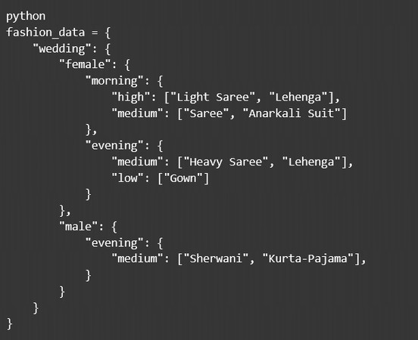
Fig. 2. Structure of the Python dictionary used for fashion rule mapping

CHAPTER 4

RESULTS AND DISCUSSION

The prototype system was evaluated using a set of sample test cases to determine its effectiveness in recommending appropriate attire.

During testing, different combinations of input parameters such as occasion, gender, and time of day were provided to the system. The system then generated outfit recommendations based on the rule-based mapping stored in the Python dictionary. For example:

Input: Wedding, Female, Morning Output: Light Saree, Lehenga Input: Interview, Male, Morning Output: Formal Shirt, Tie, Blazer Input: Party, Female, Night Output: Cocktail Dress, Saree

The evaluation involved approximately twenty test cases. Out of these, sixteen recommendations matched user expectations. This resulted in an estimated accuracy of around 80% .
The response time of the system was extremely fast because dictionary lookup operations require minimal computational resources. Memory consumption was also very low since the rule database contained only a limited number of entries.
The results demonstrate that a rule-based fashion recommendation system can effectively provide contextual clothing suggestions while maintaining simplicity and efficiency.

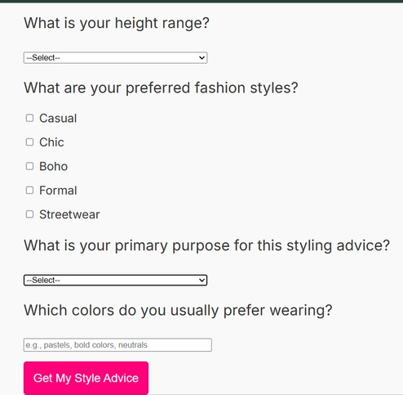
Fig. 3. Quiz for user filtering based on occasion

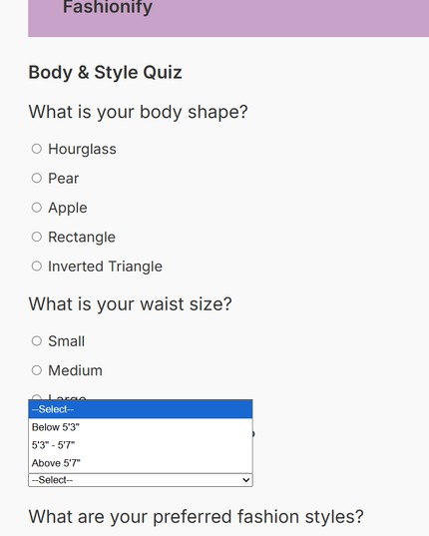
Fig. 4. Quiz for user filtering based on body type

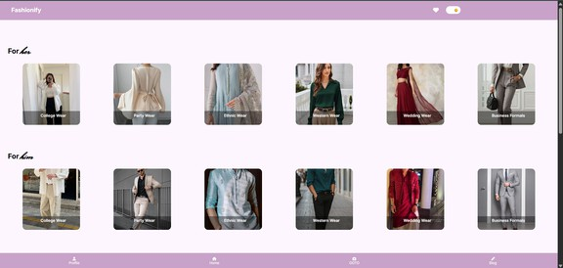
Fig. 8.
Fig. 5. Recommended Men and women wears

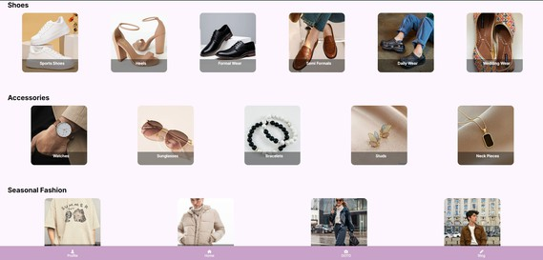
Fig. 6. Accessories and seasonal recommendations

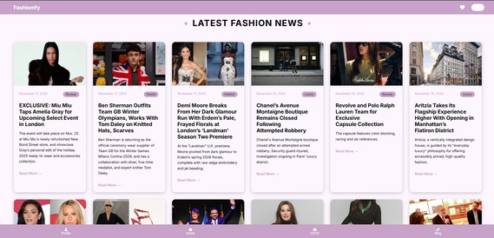
Fig. 7. Latest Fashion news fetched through NewsAPI

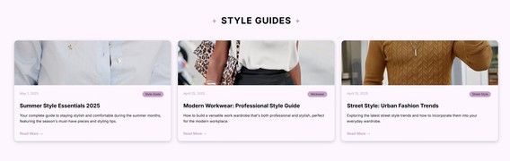
Fig. 8. Latest Style Guide

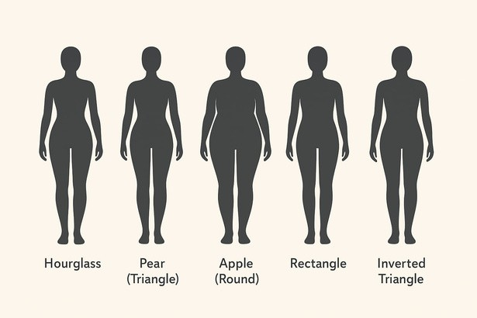
Fig. 9. Body Types

CHAPTER 5

CONCLUSION AND FUTURE SCOPE

Conclusion

The system we designed here proved that by using a Python dict based rule-engine a Virtual Fashion Advisor that accounts for cultural and context-appropriate considerations for ensembles and their components can be designed at negligible computational cost. Rulesets are also easily under- stood, explainable and transparent, providing a good baseline accuracy of 80% and can be used to help avoid decision fatigue in the initial stages of recommending outfits to a user for different occasions. Hybrid approaches or fully API/data- driven ML pipelines do have merits and may supersede the current model in the long run in terms of flexibility, up-to- date responsiveness to trends and user personalization. This light-weight and intuitive rule- based system can serve well for a basic system or bootstrapped prototype. The modular and component based architecture defined in this paper is extensible. Future extensions will focus on including ML models, CV for body-type estimation, and more comprehensive curated

datasets. A hybrid model—using a combination of rule-engine with tunable ML components, and API for updates—could be a path forward to a more personalized, scalable, and fully automated Fashion Recommender.

Future Scope

Several improvements can be made to enhance the functionality and accuracy of the system.
Future versions of the system may incorporate machine learning algorithms such as collaborative filtering and reinforcement learning to provide personalized fashion recommendations based on user behavior and preferences.

Computer vision techniques can also be used to analyze body shape and recommend clothing styles that best suit individual body types. Integration with augmented reality technology can enable virtual try-on features, allowing users to visualize how an outfit would look before making a decision.

Additionally, weather-based clothing recommendations can be implemented by integrating real-time weather APIs. The system can also be expanded into a full-scale web or mobile application using modern frameworks such as Flask, Django, React, or Flutter.
These improvements will make the Virtual Fashion Advisor more intelligent, personalized, and useful for real-world applications.

REFERENCES

- J. McAuley, et al., “Image-based recommendations on styles and substitutes,” SIGIR, 2015.

- Q. Chen and L. Li, “AI in Fashion: From Style Transfer to Virtual Try- On,” Journal of Fashion Technology, 2021.

- Myntra Fashion Recommendation Documentation.

- Amazon AI – Personalized Recommendations in E-commerce.

- S. Russell and P. Norvig, Artificial Intelligence: A Modern Approach, 3rd ed., 2016.

- Y. Ding, Z. Lai, P. Y. Mok, and T.-S. Chua, “Computational Technologies for Fashion Recommendation: A Survey,” arXiv:2306.11234, 2023.

- Y. Deldjoo, et al., “A Review of Modern Fashion Recommender Sys- tems,” arXiv:2201.00045, 2022.

- B. Suvarna, et al., “Enhanced Content-Based Fashion Recommendation Using Deep Learning,” Fashion and Textiles, Springer, 2024.

- M. Ozcinar and G. Anbarjafari, “Generative AI-based Style Recommen- dation Using Fashion Item Detection and Classification,” ResearchGate preprint, 2024.

- X. Han, et al., “ViBE: Dressing for Diverse Body Shapes,” arXiv:1912.06697, 2019.

- Z. Al-Halah, et al., “Fashion is Taking Shape: Understanding Clothing Preference Based on Body Shape from Online Sources,” arXiv:1807.03235, 2018.

- L. Smith, et al., “Human Body Shape Classification from a Single Image,” arXiv:2305.18480, 2023.

- A. Reimann, et al., “Improving the Learnability of Machine Learning APIs by Semi-Automated API Wrapping,” arXiv:2203.15491, 2022.

- S. Wazarkar, et al., “Advanced Fashion Recommendation System for Different Body Types Using Deep Learning Models,” ResearchGate, 2022.

- S. Jogi, et al., “AI-Powered Body Type Analysis for Fashion Recommen- dation,” International Journal of Information Science and Technology, 2025. (Online link pending)

- R. Wang, et al., “FrugalML: How to Use ML Prediction APIs More Accurately and Cheaply,” arXiv:2006.07512, 2020.

- R. Kanter, et al., “ML 2.0: Engineering Data-Driven AI Products,” arXiv:1807.00401, 2018.

- IEEE Spectrum, “AI-Generated Fashion Is Next Wave of DIY Design,” Oct. 29, 2022.

- IEEE, “IEEE Editorial Style Manual for Authors,” 2019.

APPENDIX 1

